Supplementary Material 3
This supplementary material accompanies the article:
Benet, D., Migadel, K. and Costa, F. (2026) “VolcAshDB open services for visualization and Machine Learning–driven classification of volcanic ash particles”, Volcanica, 9(2), pp. 597–611. doi: 10.30909/vol/jvso2431.
Benet et al., [2026] should be cited if this material is re-used.

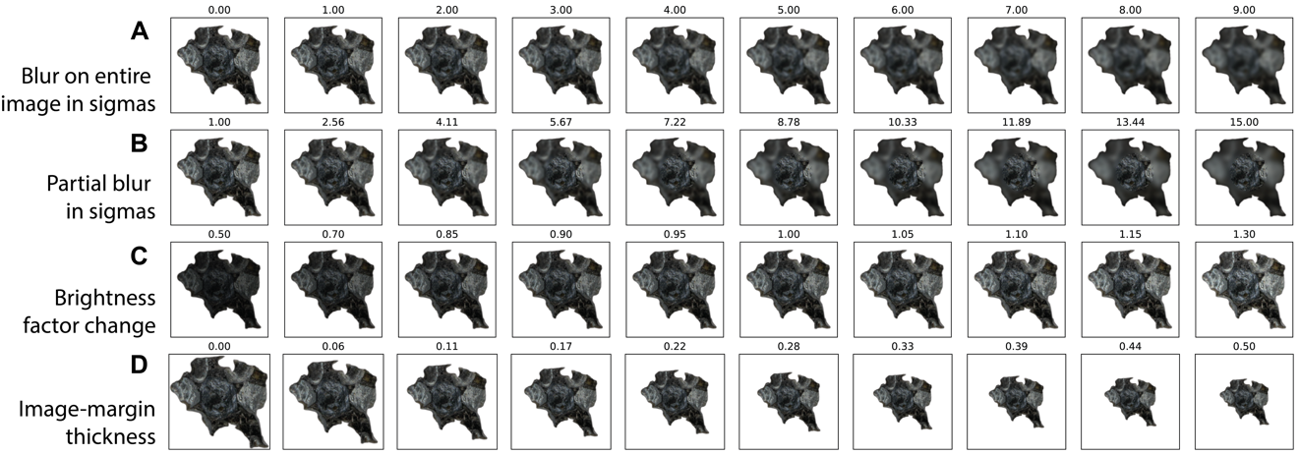
Figure S1: Gradual changes from the initial image (top-left) through four types of transformation, including (A) blur of the entire image, (B) partial blur as a proxy for single-focus image, (C) brightness factor, and (D) thickness of the margin.

