*This Supplementary Material accompanies the article*

“*Distinguishing shallow from mid-crustal magmatic processes at Soufrière Hills Volcano using Finite Element Modelling and co-analysis of EDM and GPS data*” by A. Johnson, J. Hickey, K. Pascal, B. Williamson, and R. Syers. The original article should be cited if this material is used:

Johnson, A., Hickey, J., Pascal, K., Williamson, B. and Syers, R. (2023) “Distinguishing shallow from mid-crustal magmatic processes at Soufrière Hills Volcano using Finite Element Modelling and co-analysis of EDM and GPS data”, Volcanica, 6(2), pp. 265–282. doi: 10.30909/vol.06.02.265282

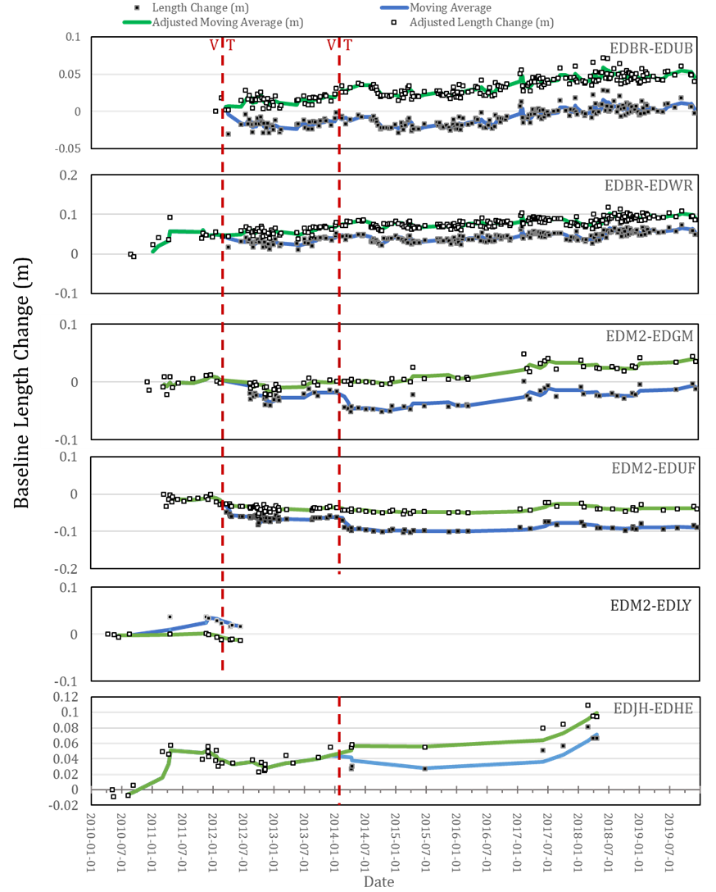

Supplementary Figure S1. Observed EDM baseline changes between 2010 and 2019. Red dashed lines mark the points of significant volcanotectonic (VT) events that were corrected for in the EDM measurements (March 2012 and March 2014). The 3-point moving average for the raw length change is shown in blue, and the 3-point moving average for the adjusted data is shown in green.

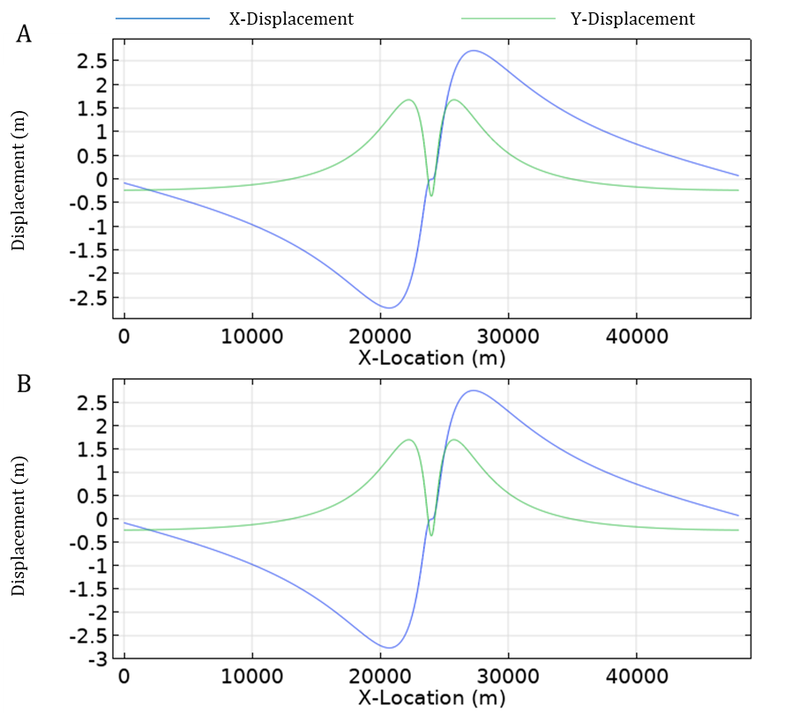

Supplementary Figure S2. Comparison of deformation responses of differing dyke thicknesses. Previous literature estimated the thickness of the dyke conduit at the SHV at 2 m [Costa et al, 2007; Hautmann et al, 2009], but mesh density limitations meant the dyke used in our modelling was 50 m thick. We therefore set out to quantify the difference the increased dyke thickness would make using a simple 2D FEM with a linear elastic medium. A.) Deformation response of a 2 m wide dyke extending from 500 m below the free surface to 4500 m, pressurised at 10 MPa. B.) Deformation response of a 50 m wide dyke extending from 500 m below the free surface to a depth of 4500 m, pressurised at 10 MPa. There is no substantial difference in deformation response from increasing the dyke thickness alone.

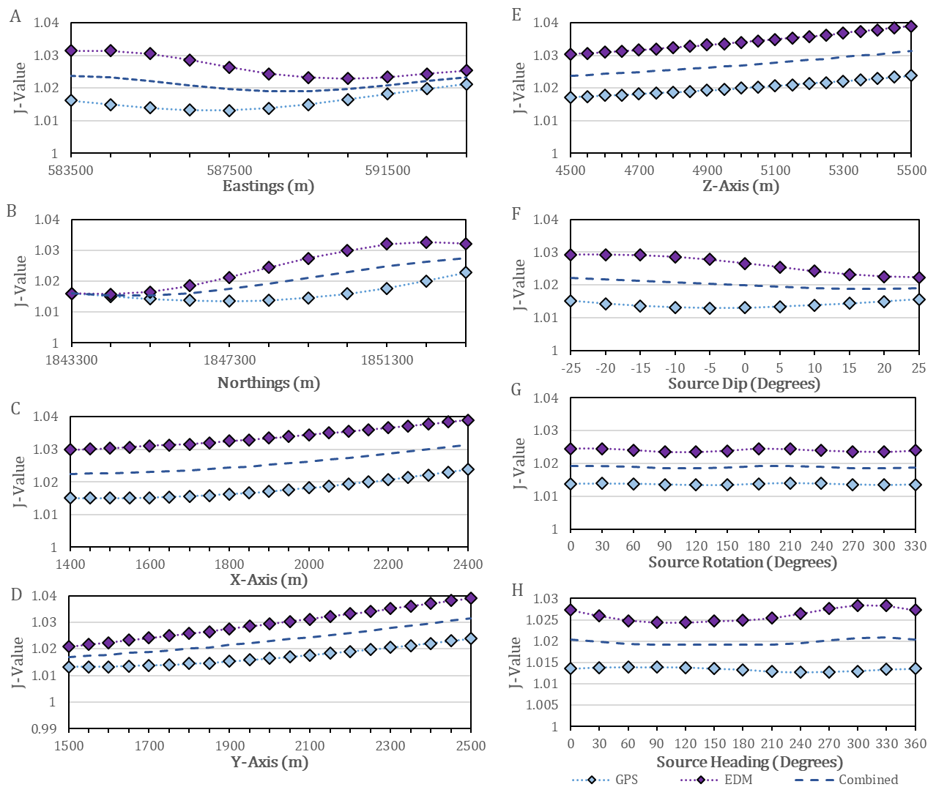

Supplementary Figure S3. Remaining mid-crustal source variation from initial (step 1a) sensitivity test results. A.) X-Position of source. B.) Y-Position of Source. C.) X-Axis of Source. D.) Y-Axis of Source. E.) Z-Axis of Source. F.) Source Dip. G.) Source Rotation. H.) Source Heading. Source pressurisation and depth are presented in Figure 6 of the paper.

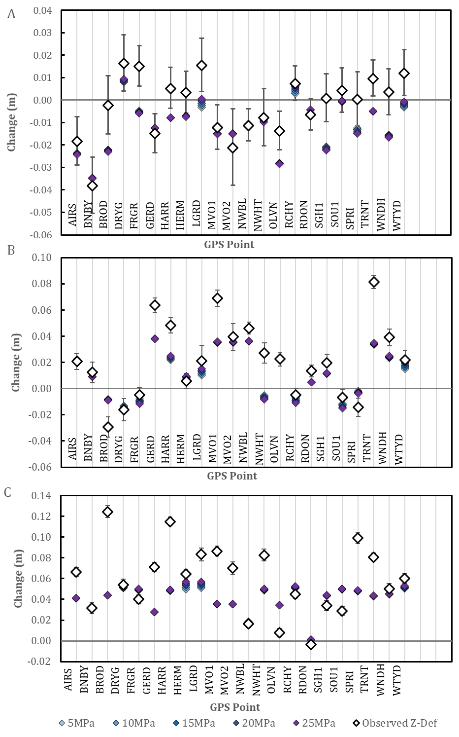

Supplementary Figure S4. Variation of pressure in a shallow reservoir. GPS results for pressure variation in a shallow spherical reservoir centred at a depth of 1500 m, with a fixed deep prolate source centred at a depth of 9500 m and pressurised at 10 MPa incorporated into the model. Showing A.) Modelled east-west deformation of GPS sites. B.) North-south deformation. C.) Vertical deformation. The GPS network is almost entirely unresponsive to not only pressure changes, but all parameter changes, in a shallow reservoir source. The only two sites to show measurable deformation responses are HERM and LGRD, the two GPS sites situated closest to the vent. These results suggest the GPS network is not well-placed to respond to changes in a shallow reservoir source.

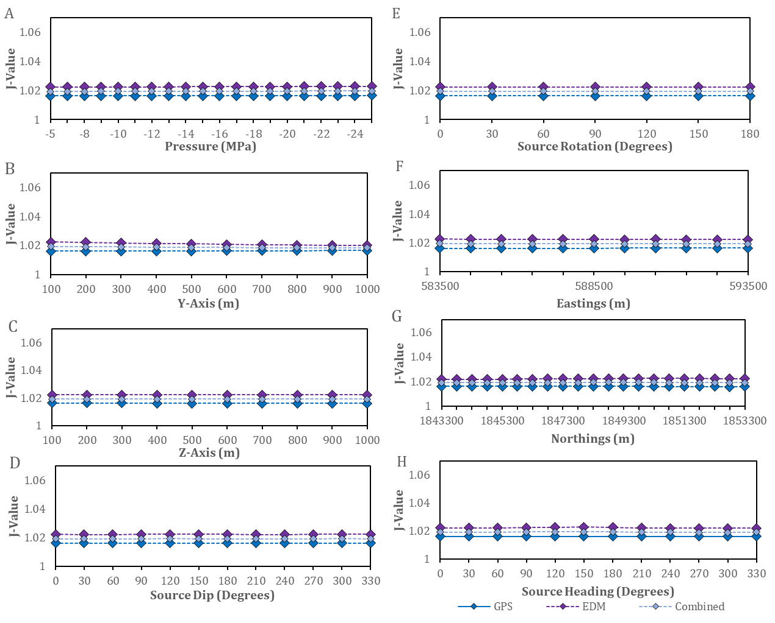

Supplementary Figure S5. Remaining shallow reservoir sensitivity test results. Remaining results of sensitivity tests of parameter variation of a shallow reservoir source, in conjunction with a fixed prolate deep source. A.) Negative Pressurisation. B.) Y-Axis of source. C.) Z-Axis of source (where Z-Axis ˃ 500 m = Oblate, Z-Axis = 500 m = Spherical, Z-Axis ˂ 500 m = Prolate). D.) Source Dip. E.) Source Rotation. F.) X-Location. G.) Y-Location. H.) Source Heading. Results for positive pressurisation, depth variation, and X-Axis variation are presented in Figure 7 in the paper.

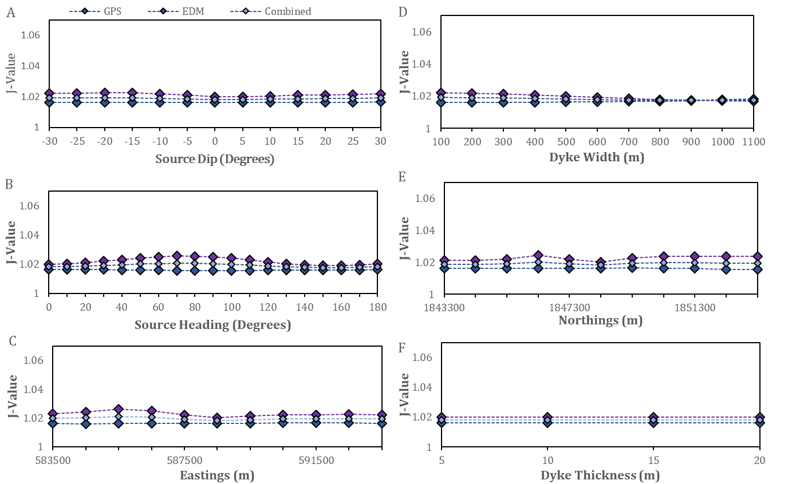

Supplementary Figure S6. Remaining shallow dyke conduit sensitivity test results. Remaining results of sensitivity tests of parameter variation of a shallow dyke conduit source, in conjunction with a fixed prolate deep source. A.) Source Dip. B.) Source Heading. C.) X-Position of Source. D.) Dyke Width. E.) Y-Location of Source. F.) Dyke Thickness. Results for source pressurisation, depth variation, and source rotation are presented in Figure 8 in the paper.

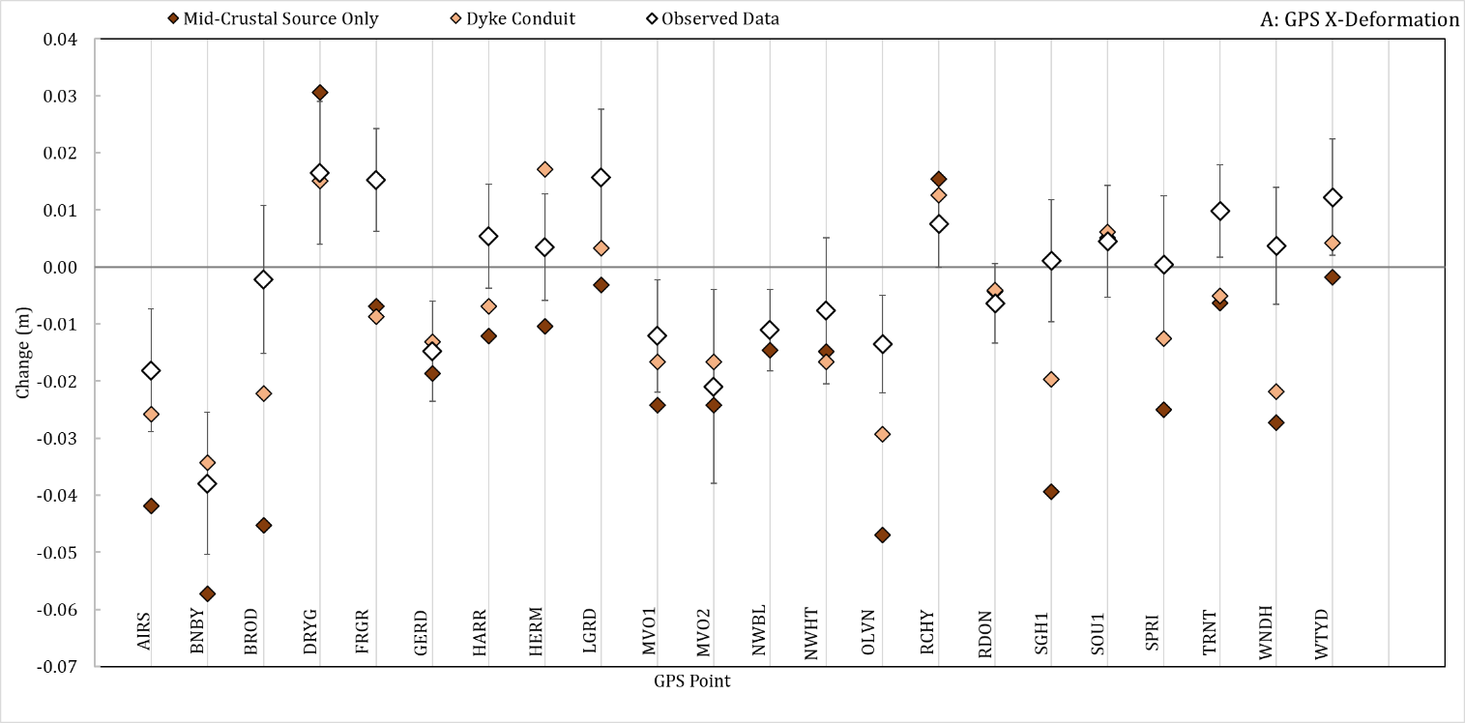

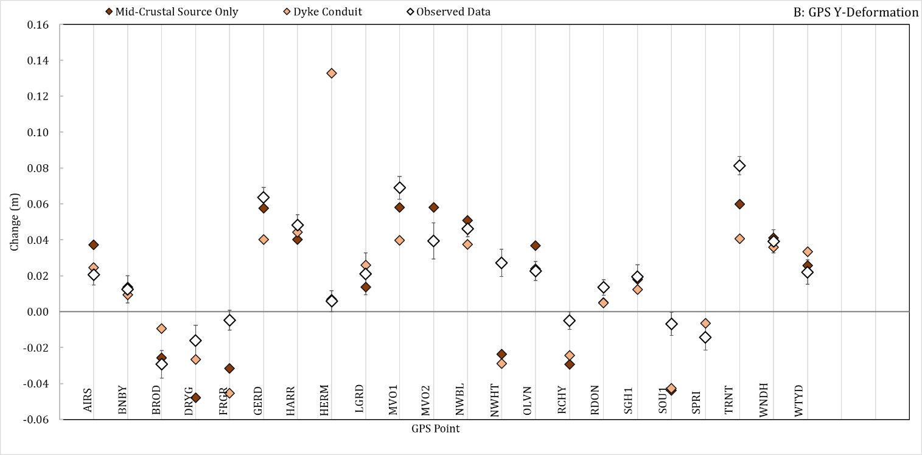

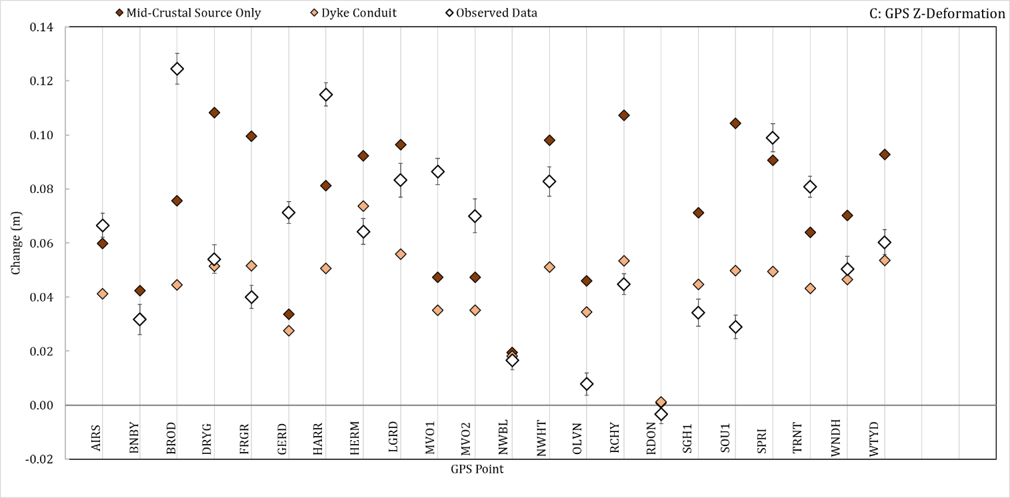

Supplementary Figure S7. Comparison of best fit results for GPS data for modelling the mid-crustal source in isolation, the mid-crustal and dyke conduit together, and the observed data collected by Montserrat Volcano Observatory. A.) East-West/X Deformation of GPS points. B.) North-South/Y Deformation of GPS Points. C.) Vertical/Z Deformation of GPS Points.

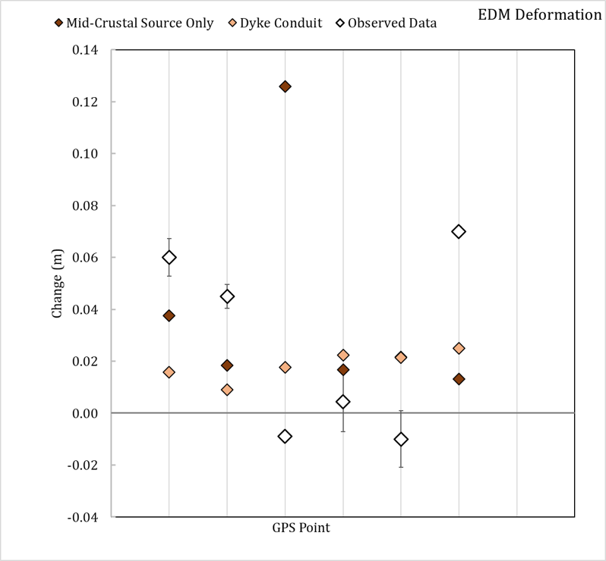

Supplementary Figure S8. Comparison of best fit results for EDM data for modelling the mid-crustal source in isolation, the mid-crustal and dyke conduit together, and the observed data collected by Montserrat Volcano Observatory.